**Week 1**

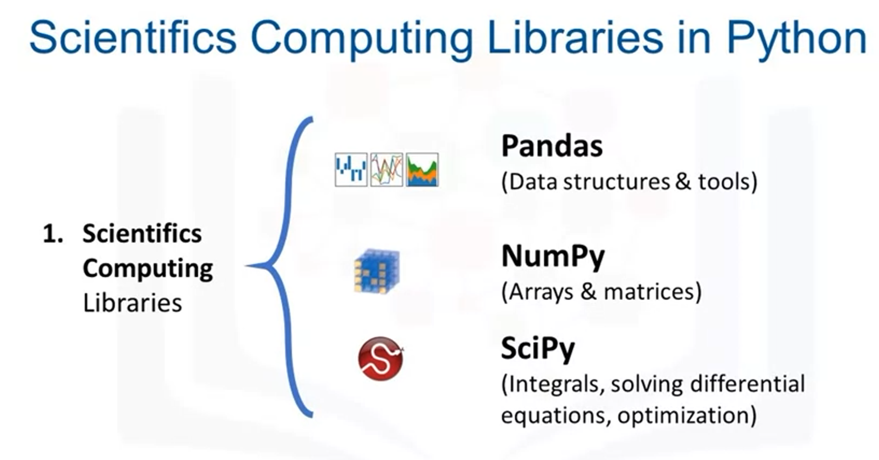

From test:

**Probably SciPy:** Includes functions for some advanced math problems as listed in the slide as well as data visualization.

**Pandas:** Offers data structure and tools for effective data manipulation and analysis. It provides fast access to structured data. The primary instrument of Pandas is a two-dimensional table consisting of columns and rows labels which are called a DataFrame. It is designed to provide an easy indexing function.

**Probably NumPy:** Uses arrays as their inputs and outputs. It can be extended to objects for matrices, and with a little change of coding, developers perform fast array processing.

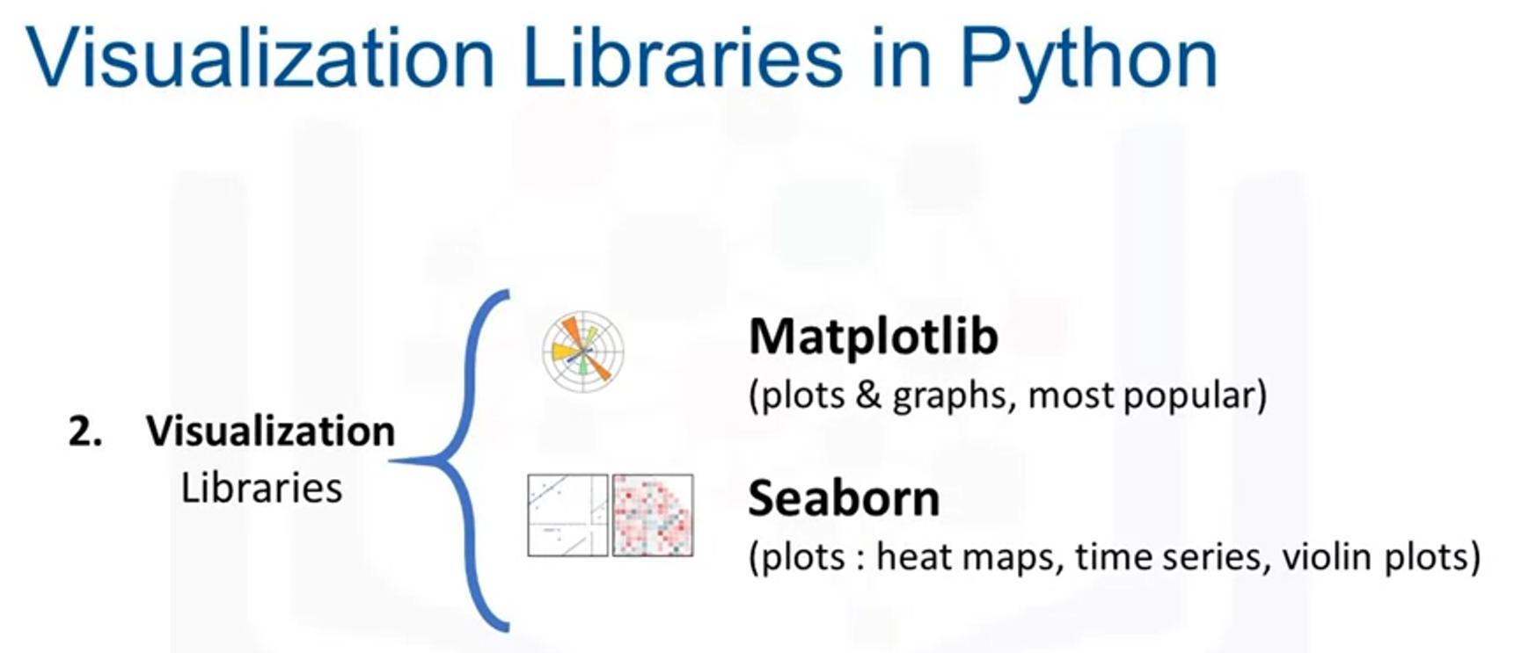

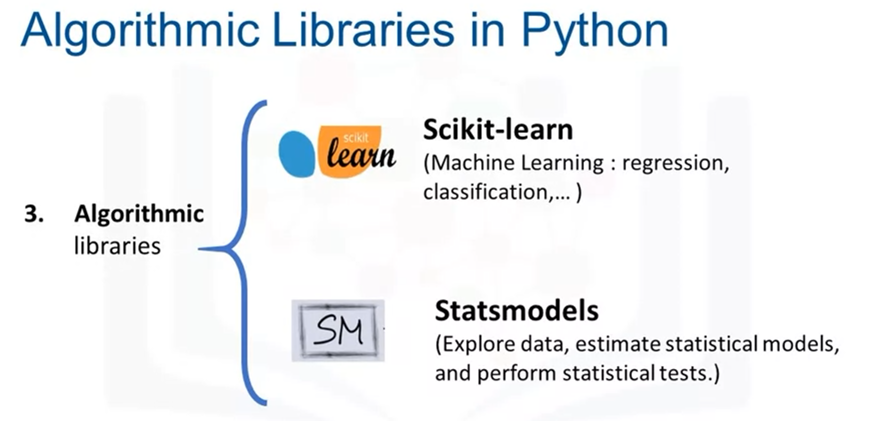

**Pandas**

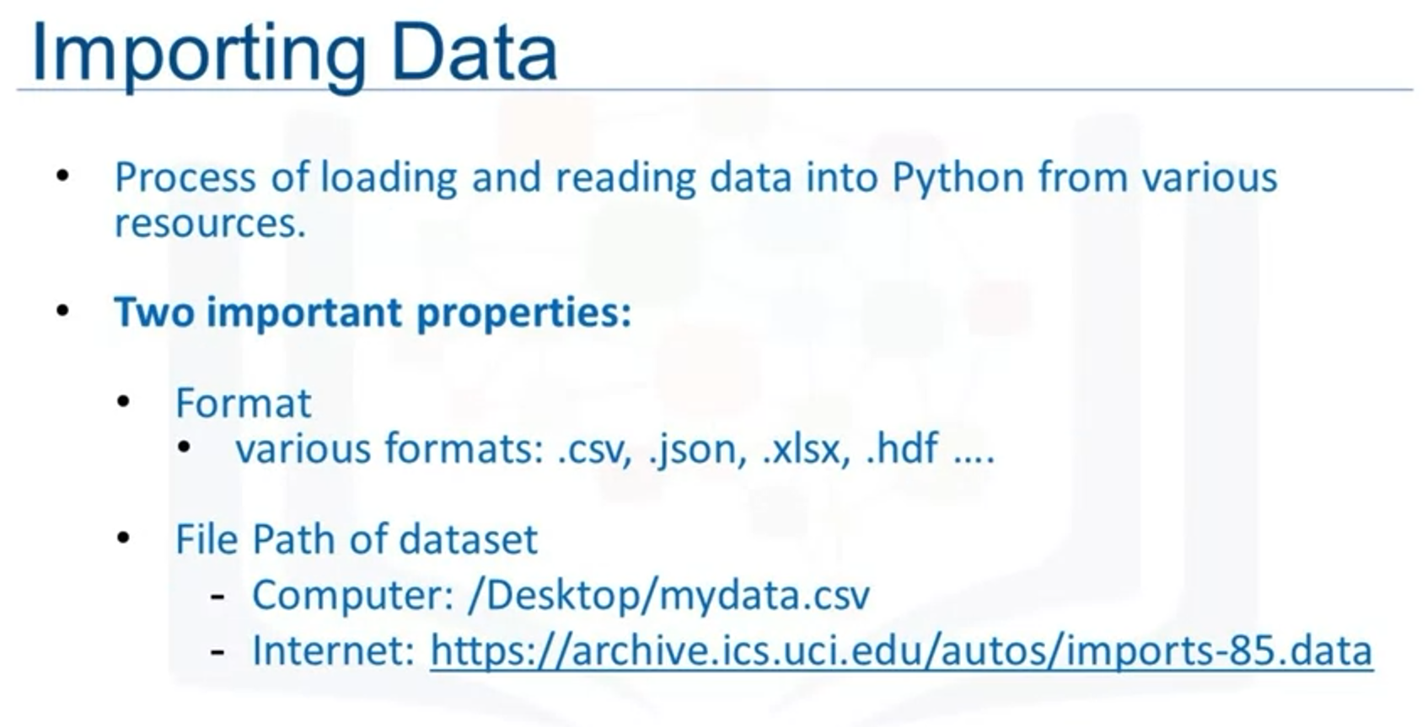

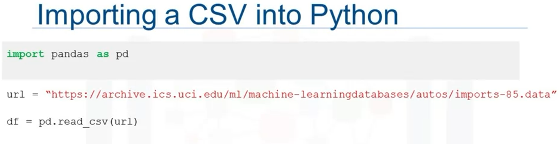

**read_csv** command assumes the data contains headers.

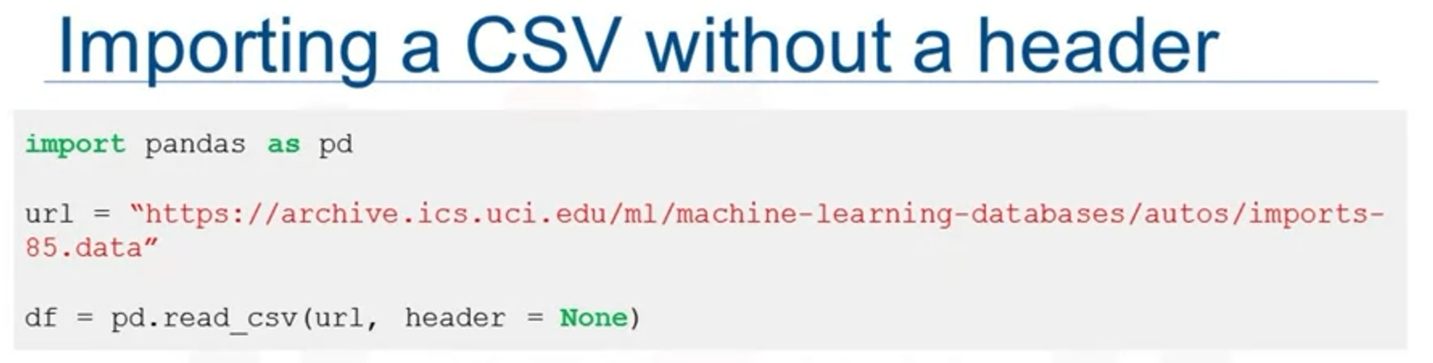

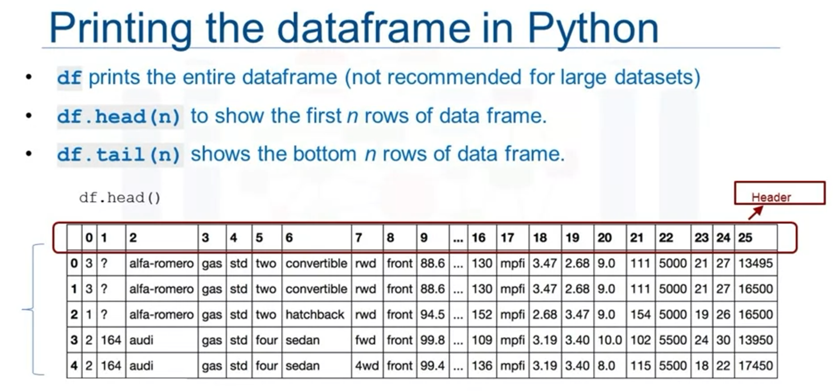

Because Header = None we have a header 0-25 instead of a real header.

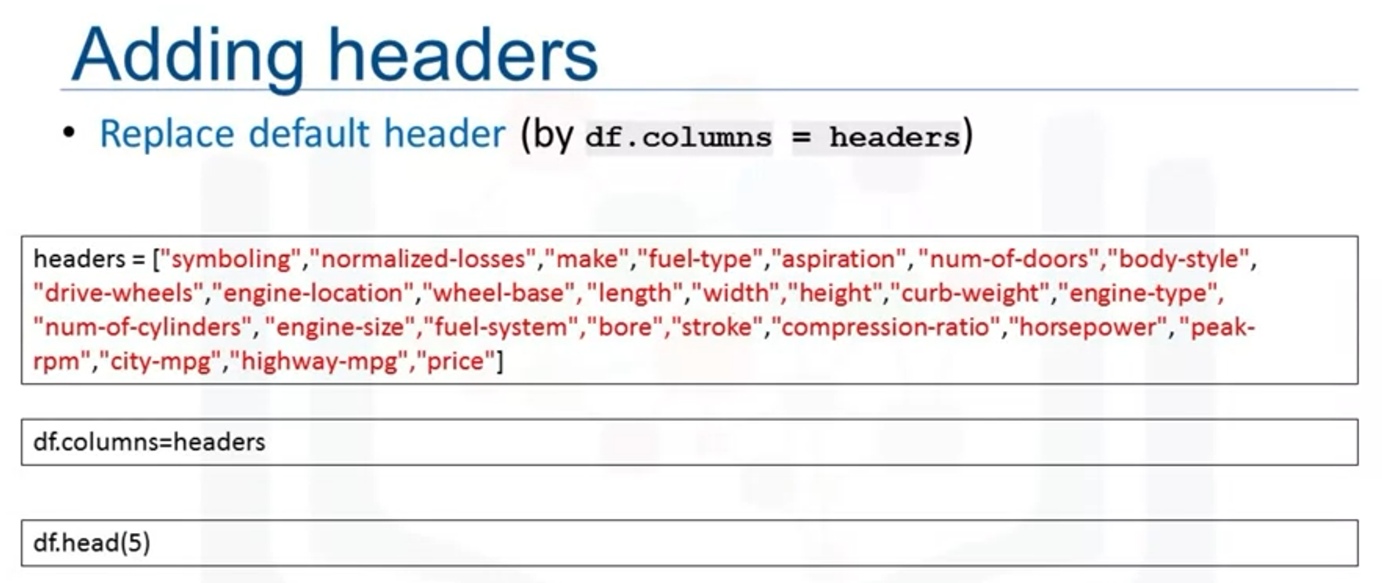

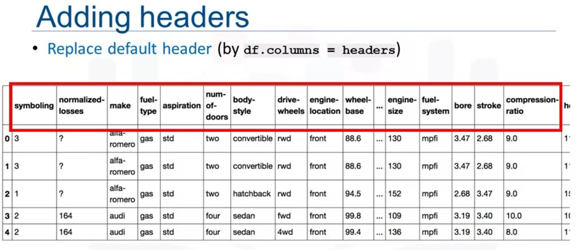

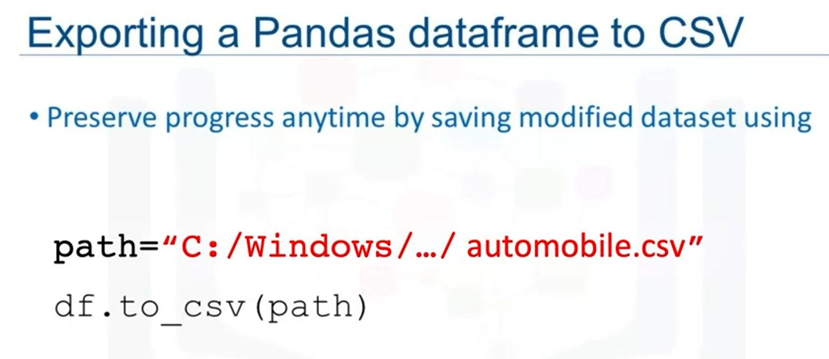

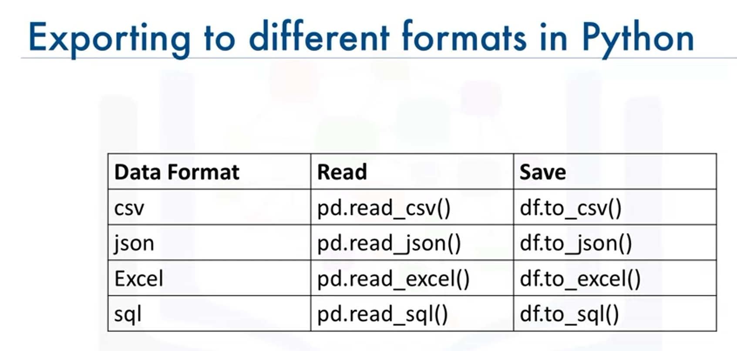

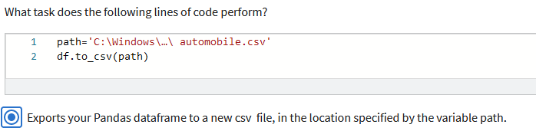

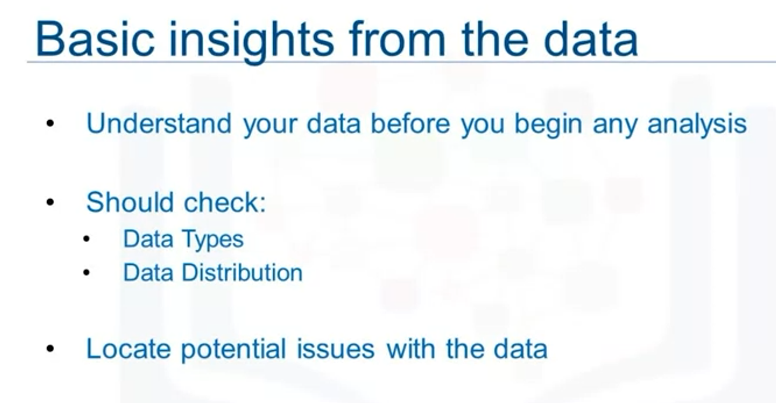

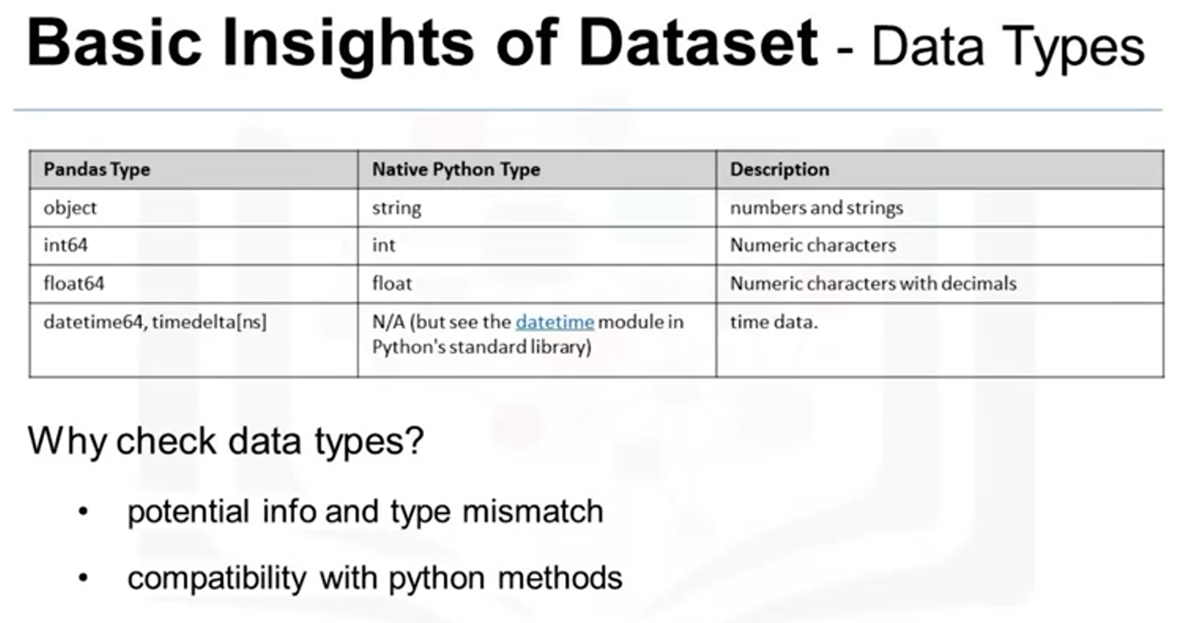

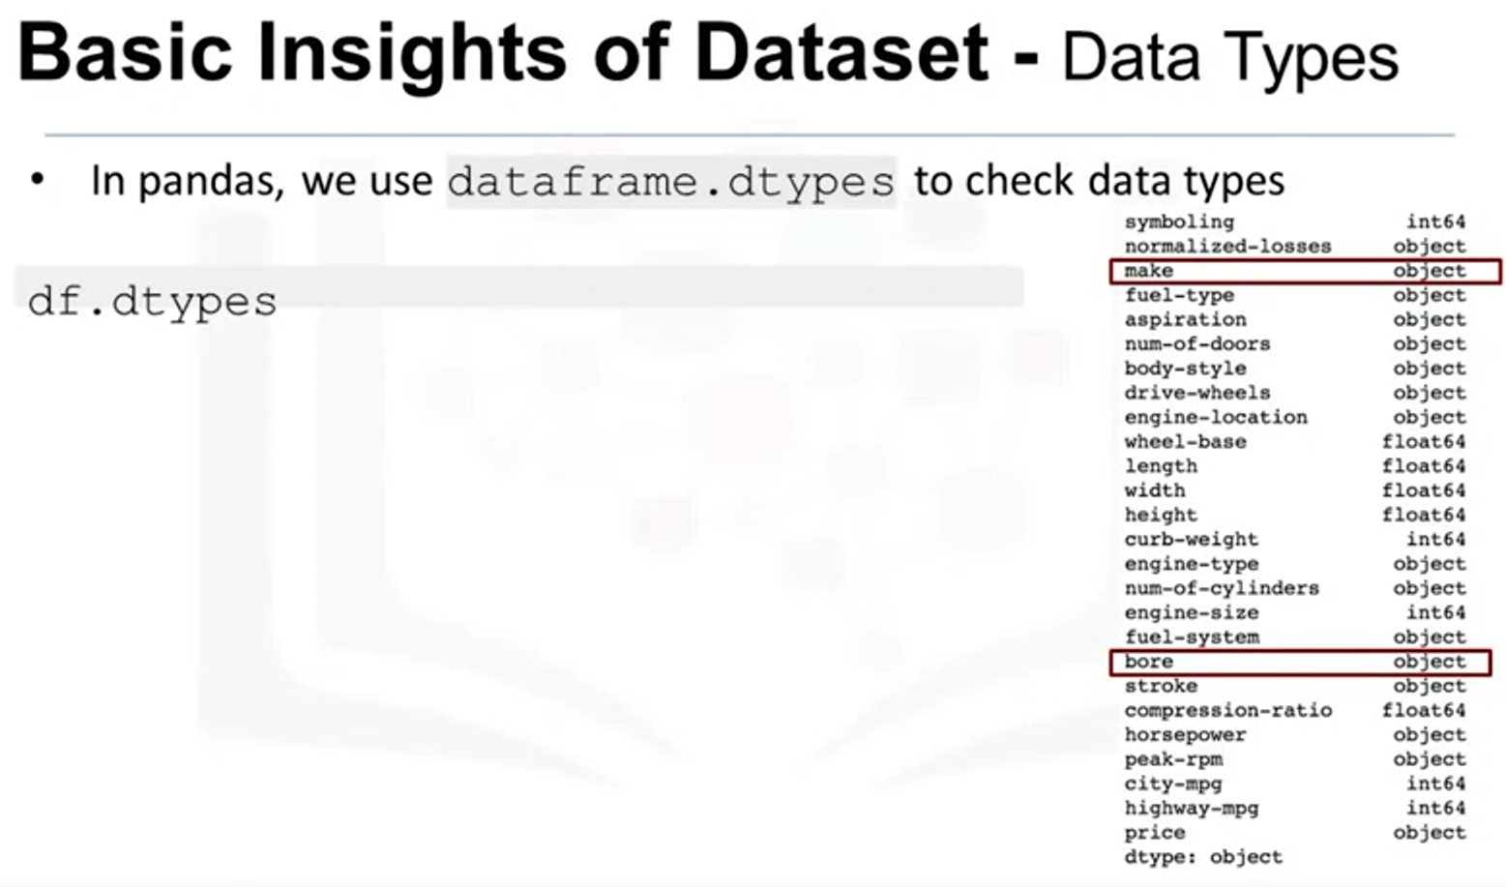

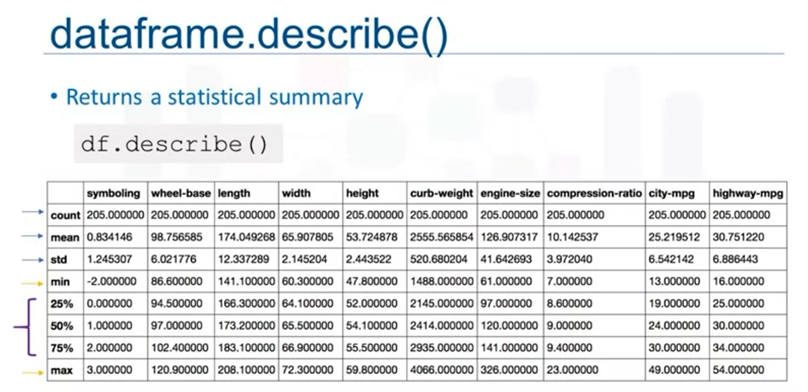

**Include=”all”** includes columns that have textual data (datatype **object**):

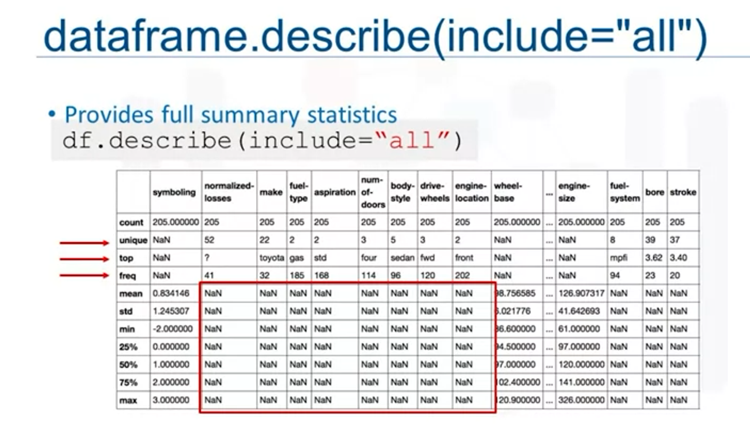

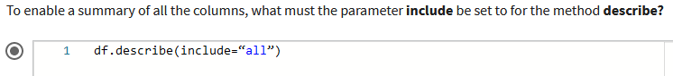

**NaN** = not a number.

Top and bottom 25 rows of the dataframe:

